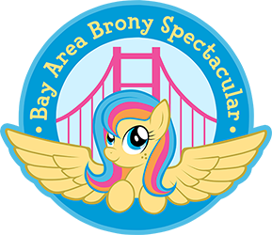 Handler Needed ___

**Closet Cosplay Entry**

**Bay Area Brony Spectacular 2015**

Please bring this form to the cosplay contest

|  |
| --- |
| General Information |
| Name: |
| Number: |
| Character: |
| Media Name: (If from media other than FIM such as Comics, Fanfiction, previous generation, etc) |
| Costume made by: |
| Email: |

I have read and understand the Cosplay Contest rules for Bay Area Brony Spectacular 2015. I grant Bay Area Brony Spectacular the complete right to use and publish any photographs of me for editorial, trade, advertising, or any other purpose or medium; to alter the same without restriction; and to copyright the same. I hereby release Bay Area Brony Spectacular from all claims and liability relating to said photographs.

Group Leader’s Signature:

Parent/Guardian signature if under 18: