Handler Needed   
(Circle for fursuitors, limited mobility, etc.)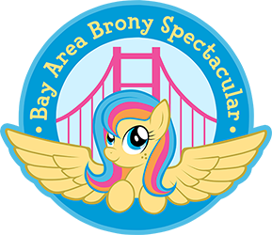

**Individual Entrant**

**Bay Area Brony Spectacular 2015**

*Please bring this form to Pre-Judging*

|  |
| --- |
| General Information |
| Name: |
| Number: |
| Character: |
| Media Name: (If from media other than FIM such as Comics, Fanfiction, previous generation, etc) |
| Costume made by: |
| Email: |

|  |  |  |  |  |
| --- | --- | --- | --- | --- |
| Skill Level |  |  |  |  |
| Youth | Beginner | Intermediate |  | Master |

I have read and understand the Cosplay Contest rules for BABScon 2015. I grant BABScon the complete right to use and publish any photographs of me) for editorial, trade, advertising, or any other purpose or medium; to alter the same without restriction; and to copyright the same. I hereby release BABScon from all claims and liability relating to said photographs.

Signature: 

Parent/Guardian signature if under 18: 