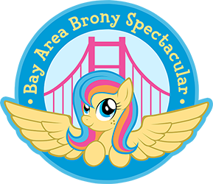 Handler Needed ___

**Group Entry**

**Bay Area Brony Spectacular 2015**

Please bring this form to Pre-Judging

|  |
| --- |
| General Information |
| Group Name: |
| Media Name: (If from media other than FIM such as Comics, Fanfiction, previous generation, etc) |
| Costumes made by: |

|  |  |  |  |
| --- | --- | --- | --- |
| Group | Information |  |  |
| Entrant | Name | Character | Email |
| 1 |  |  |  |
| 2 |  |  |  |
| 3 |  |  |  |
| 4 |  |  |  |
| 5 |  |  |  |
| 6 |  |  |  |
| 7 |  |  |  |

I have read and understand the Cosplay Contest rules for Bay Area Brony Spectacular 2015. I grant Bay Area Brony Spectacular the complete right to use and publish any photographs of me for editorial, trade, advertising, or any other purpose or medium; to alter the same without restriction; and to copyright the same. I hereby release Bay Area Brony Spectacular from all claims and liability relating to said photographs.

Group Leader’s Signature:

Parent/Guardian signature if under 18: